Project Report Format
- INTRODUCTION
  - Project Overview
  - Purpose
- IDEATION PHASE
  - Problem Statement
  - Empathy Map Canvas
  - Brainstorming
- REQUIREMENT ANALYSIS
  - Customer Journey map
  - Solution Requirement
  - Data Flow Diagram
  - Technology Stack
- PROJECT DESIGN
  - Problem Solution Fit
  - Proposed Solution
  - Solution Architecture
- PROJECT PLANNING & SCHEDULING
  - Project Planning
- FUNCTIONAL AND PERFORMANCE TESTING
  - Performance Testing
- RESULTS
  - Output Screenshots
- ADVANTAGES & DISADVANTAGES
- CONCLUSION
- FUTURE SCOPE 11. APPENDIX
Source Code(if any)
Dataset Link
GitHub & Project Demo Link

PROJECT TITLE:
Measuring the pulse of prosperity: an index of economic freedom

- INTRODUCTION

1.1 Project Overview
Economic freedom refers to the ability of individuals and businesses to control their labor, property, and financial decisions with minimal government interference. Countries that promote economic freedom tend to experience higher economic growth, innovation, investment, and improved living standards.

The Index of Economic Freedom evaluates countries using indicators such as property rights, taxation, government spending, regulatory efficiency, and market openness. Understanding these indicators helps explain why some countries prosper while others struggle economically.

This project analyzes global economic freedom data along with economic indicators such as GDP growth, inflation, unemployment, and monetary stability. Using data visualization techniques, the project presents insights through dashboards and storytelling to make complex economic data understandable and useful for decision-making.

1.2 Purpose
The purpose of this project is to simplify complex economic data and present it through interactive dashboards and visual storytelling so that users can understand economic trends, compare countries, and evaluate how economic freedom influences prosperity and development.
The project aims to support policymakers, entrepreneurs, researchers, and citizens in making informed decisions by transforming raw economic data into meaningful insights.

2. IDEATION PHASE

2.1 Problem Statement
Economic data related to taxation, inflation, unemployment, and economic freedom is complex and scattered across multiple sources. Many stakeholders find it difficult to interpret these indicators and understand how economic policies influence growth and prosperity. The lack of clear visualization tools further limits effective analysis and decision-making.

2.2 Empathy Map Canvas
Target Users
- Policymakers and government officials
- Entrepreneurs and investors
- Researchers and students
- Citizens interested in economic development
Thinks
- Why do some countries grow faster than others?
- How do policies affect economic growth?
Feels
- Confused by complex economic data
- Concerned about economic stability
- Hopeful for better economic opportunities
Says
- Transparent policies improve growth
- Economic reforms are necessary
Does
- Reads economic reports and rankings
- Compares country performance
- Researches before making decisions
Pain Points
- Complex data and regulations
- Lack of clear insights
- Difficulty comparing countries
Gains
- Better understanding of economic performance
- Improved decision-making
- Awareness of growth opportunities

2.3 Brainstorming
During brainstorming, the team explored multiple ideas including:
- Comparing economic freedom scores across countries
- Studying the relationship between freedom and prosperity
- Analyzing inflation, unemployment, and GDP trends
- Developing dashboards for visualization
- Publishing insights through a web application
3. REQUIREMENT ANALYSIS

3.1 Customer Journey Map
- The user wants to understand economic performance and growth trends.
- The user searches for economic reports and datasets.
- The user finds the data complex and difficult to interpret.
- The user accesses the dashboard to explore visual insights.
- The user understands trends and makes informed decisions.

3.2 Solution Requirements
Functional Requirements
- Collect economic freedom and economic indicator data
- Process and analyze datasets
- Generate visualizations and dashboards
- Provide filters for comparison and exploration
- Publish dashboards through a web interface
Non-Functional Requirements
- User-friendly interface
- Fast performance and responsiveness
- Reliable and accurate data presentation
- Secure and accessible system
- Scalable architecture for future expansion

3.3 Data Flow Diagram
The system follows a structured data flow:
External Data Sources → Data Processing → Database → Visualization → Web Interface → Users
Data is collected from global sources, processed and stored, visualized through dashboards, and delivered to users through a web application.

3.4 Technology Stack
Data Collection & Processing: Python, Excel
Visualization Tool: Tableau Desktop & Tableau Public
Database: MySQL / CSV / Excel
Web Development: HTML, CSS, Bootstrap
Data Sources: Heritage Foundation, World Bank
This technology stack ensures efficient data processing, visualization, and accessibility.

4. PROJECT DESIGN
4.1 Problem–Solution Fit
The project addresses the challenge of understanding complex economic indicators by transforming raw data into interactive visual dashboards. The solution helps users interpret economic performance, compare countries, and identify trends quickly and effectively.

4.2 Proposed Solution
The proposed system integrates global economic datasets, analyzes key indicators, and presents insights through dashboards and storytelling. Users can explore economic freedom trends, inflation patterns, and GDP growth relationships through an interactive web interface.

4.3 Solution Architecture
The architecture consists of layered components:
- Data Source Layer: Global economic datasets
- Processing Layer: Data cleaning and analysis
- Storage Layer: Structured data storage
- Visualization Layer: Tableau dashboards
- Presentation Layer: Web interface for user access
This architecture ensures efficient data flow and scalability.

5. PROJECT PLANNING & SCHEDULING
5.1 Project Planning
The project was developed using an agile approach divided into four sprints:
Sprint 1: Data collection and preprocessing
Sprint 2: Data analysis and comparison
Sprint 3: Dashboard development and visualization
Sprint 4: Web integration, testing, and documentation
This approach ensured systematic development and timely completion.

6. FUNCTIONAL AND PERFORMANCE TESTING
6.1 Performance Testing
- Data renders correctly across visualizations.
- Filters allow dynamic exploration and comparisons.
- Calculated fields provide accurate rankings and correlations.
- Dashboards load quickly and respond smoothly.
- Storyboard presents insights in logical sequence.

7. RESULTS
7.1 Output Screenshots
The system generates:
- Economic freedom ranking charts
- GDP growth comparison visuals
- Inflation and unemployment correlation graphs
- Interactive dashboards with filters
- Data story presenting key insights
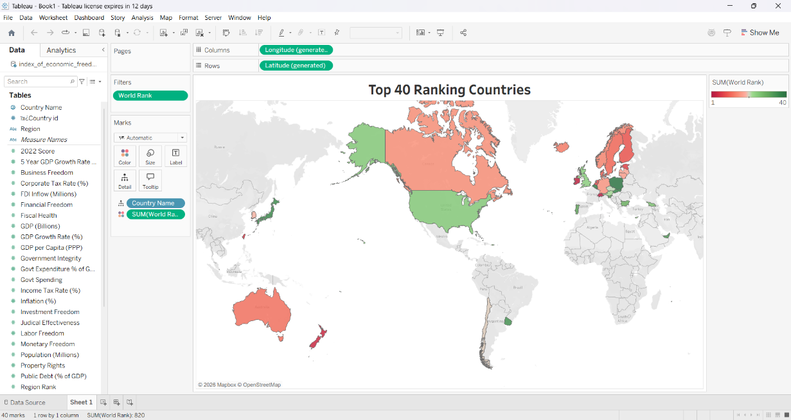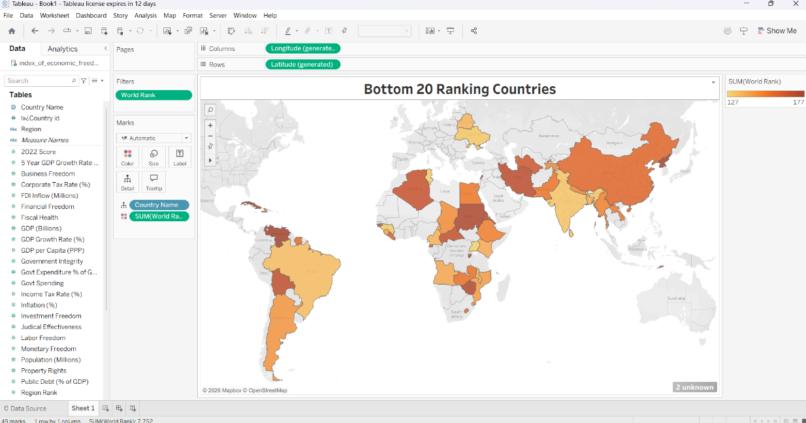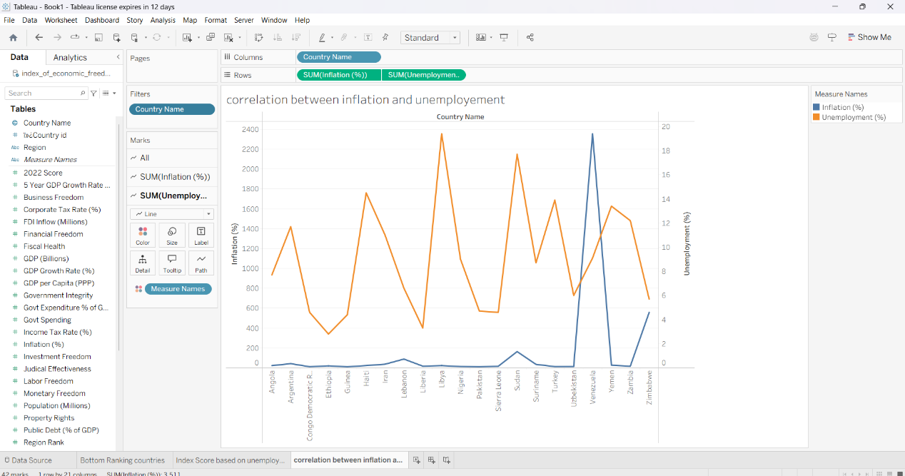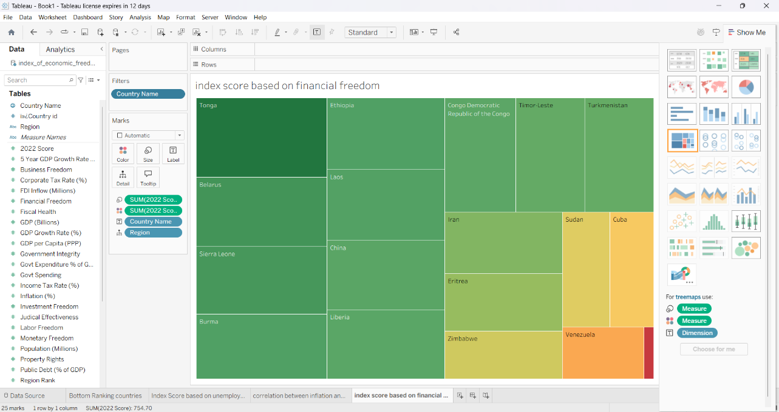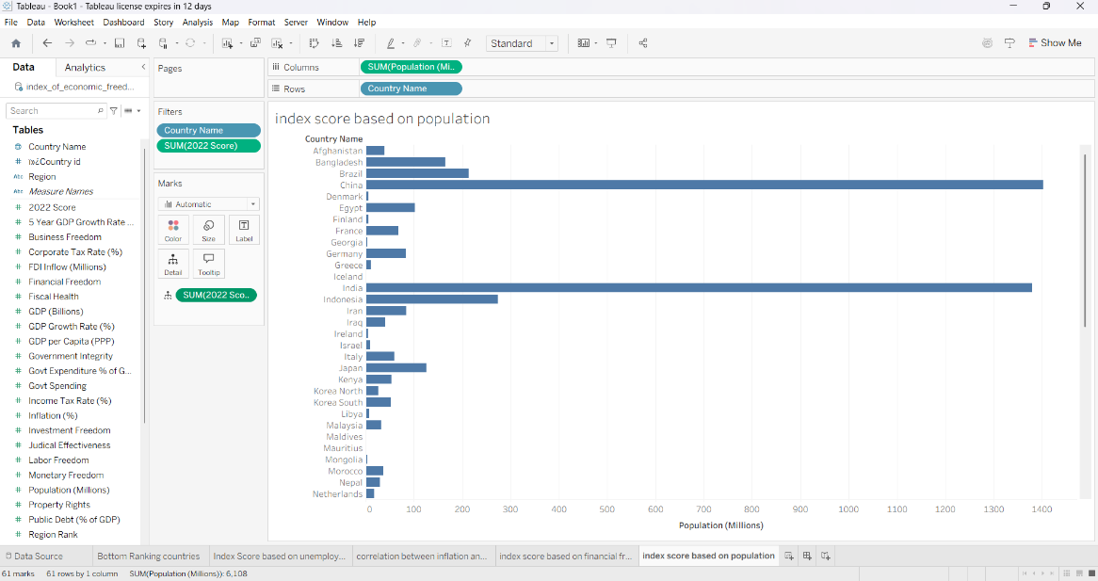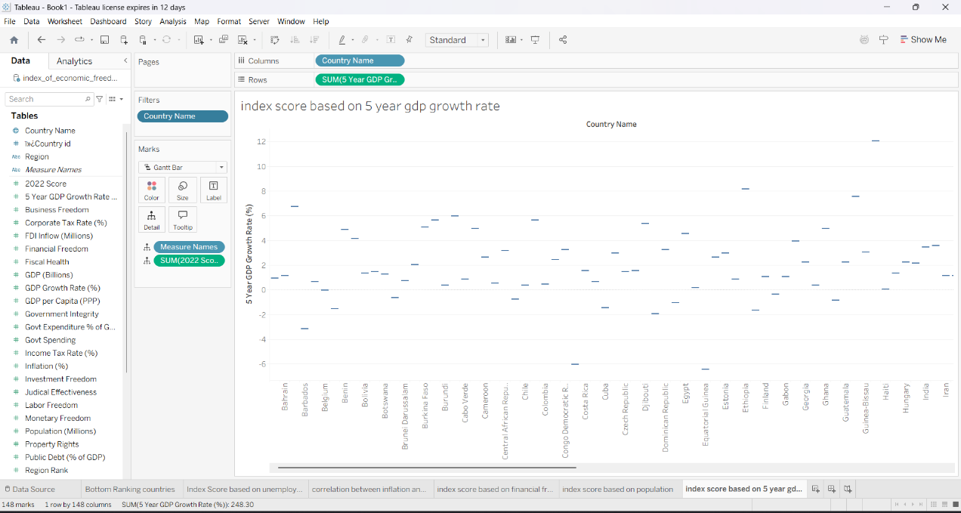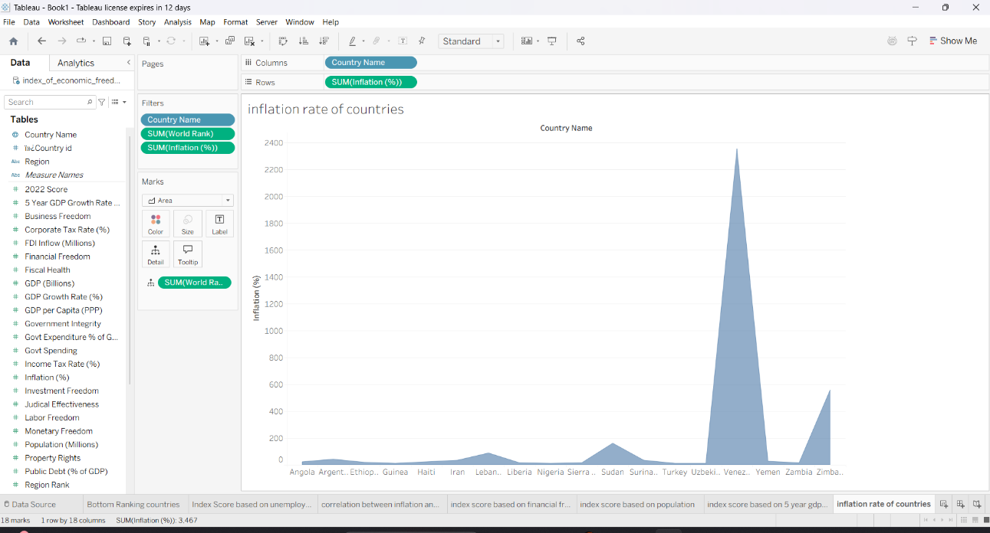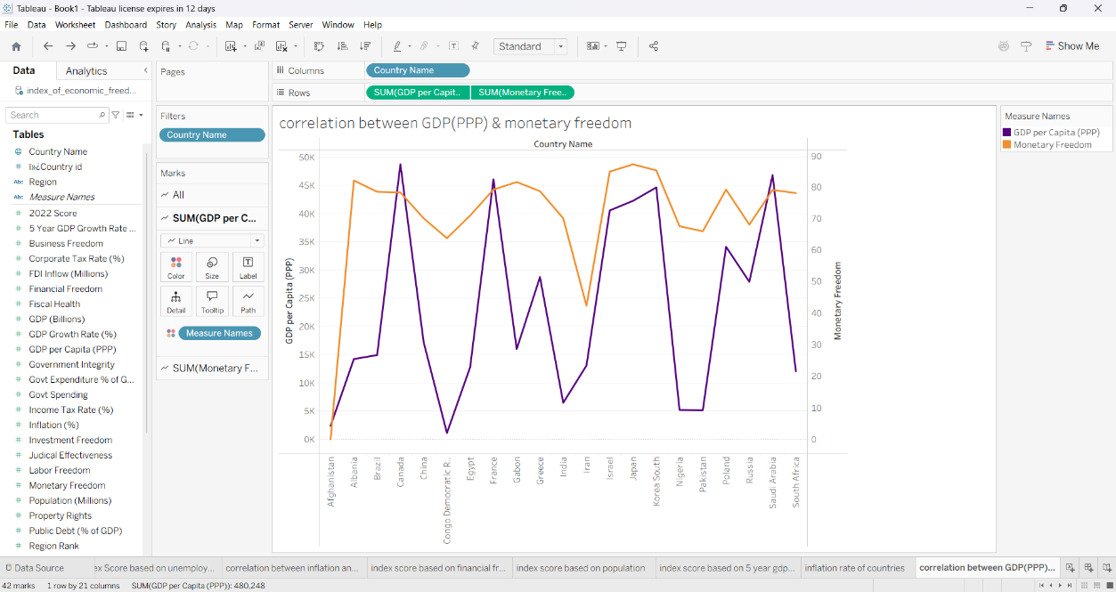

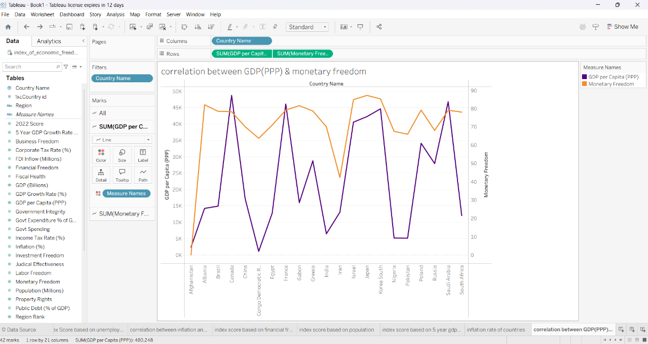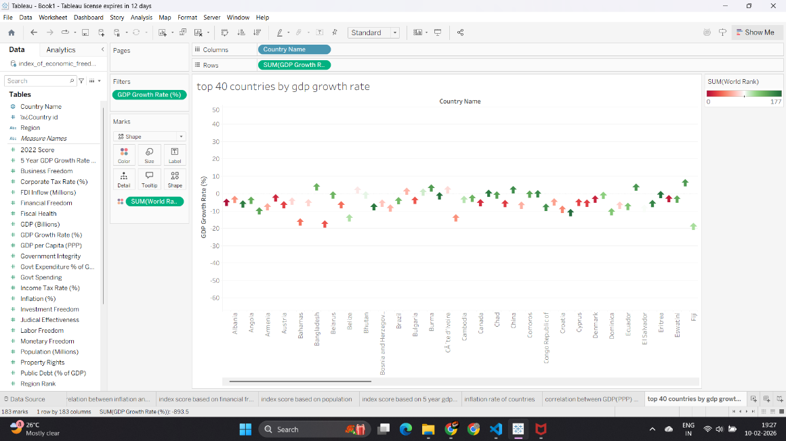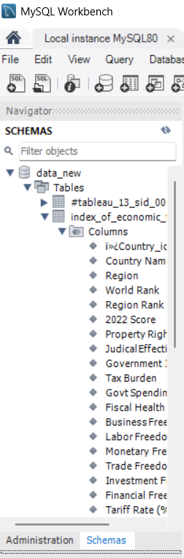
8. ADVANTAGES & DISADVANTAGES
Advantages
- Simplifies complex economic data
- Supports informed decision-making
- Provides interactive and visual insights
- Enables global comparisons
- Useful for research and policy analysis
Disadvantages
- Dependent on availability of updated data
- Requires basic data interpretation skills
- Economic indicators may change over time

9. CONCLUSION

This project demonstrates how economic freedom influences prosperity and economic development. By transforming complex economic indicators into clear visual insights, the system enables users to understand trends, compare countries, and make informed decisions. The dashboard and storytelling approach makes economic analysis accessible and meaningful.

10. FUTURE SCOPE
- Integration of real-time economic data
- Predictive analytics using machine learning
- Mobile-friendly dashboard development
- Policy recommendation system
- Expansion to additional global indicators

DataSet Link : https://drive.google.com/file/d/1EBIa1LtM3Ni2Uh3nekLB6wt3263Q3NeX/view

Github Link:

